Child Safety Policy

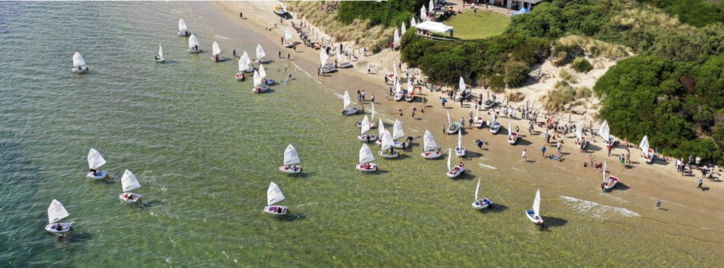

Sandy Bay Sailing Club Child Safety Policy
Updated 6th December 2022

Our commitment to child safety
Sandy Bay Sailing Club is committed to child safety.
We want children to be safe, happy and empowered.
We support and respect children, as well as our coaches and volunteers.
We are committed to the safety, participation, and empowerment of all children.
We have zero tolerance of child abuse. All allegations and safety concerns will be treated seriously, consistent with our robust policies and procedures.
When our community has concerns about a child’s safety, we have legal and moral obligations to report these concerns to the authorities.
Sandy Bay Sailing Club is committed to the prevention of child abuse through the early identification and removal of risks.
Sandy Bay Sailing Club has robust practices to reduce the risk of child abuse by new and existing committee members, administrative staff, coaches and volunteers.
Sandy Bay Sailing Club is committed to training and education of team members on child abuse risks.
We are committed to the cultural safety of Aboriginal children and those from culturally and / or linguistically diverse backgrounds and to providing a safe environment for children with a disability.
If you believe a child is at immediate risk, phone 000.

Our children
As an organisation for young people, the children of the Sandy Bay Sailing Club are of vital importance to the Club. We involve them when making decisions, especially about matters that directly affect them. We listen to their views and respect what they have to say.
We promote diversity and acceptance at the Sandy Bay Sailing Club, and people from all walks of life and cultural backgrounds are welcome. In particular, we:
- Promote the cultural safety, participation and empowerment of Aboriginal children
- Promote the cultural safety, participation and empowerment of children from culturally and / or linguistically diverse backgrounds
- Ensure that children with a disability are safe and can participate equally
This policy is intended to empower children, who are vital and active participants at the Sandy Bay Sailing Club

Our staff, coaches and volunteers
This policy guides our staff, coaches and volunteers on how to behave with children at the Sandy Bay Sailing Club.
All of our staff, coaches and volunteers must agree to abide by our code of conduct which specifies the standards of conduct required when working with children. All staff and volunteers, as well as children and their families, are given the opportunity to contribute to the development of the code of conduct.

Training and supervision
Training and supervision is important to ensure that everyone at the Sandy Bay Sailing Club understands that child safety is everyone’s responsibility.
Our organisational culture aims for all committee members, staff, coaches, volunteers, families and children to feel confident and comfortable in discussing any allegations of child abuse or child safety concerns. We train our committee members, staff, coaches and volunteers to identify, assess and minimise risks of child abuse and to detect potential signs of child abuse.
We also support our committee members, staff, coaches and volunteers through ongoing supervision to develop their skills to protect children from abuse and promote the cultural safety of Aboriginal children, the cultural safety of children from linguistically and / or diverse backgrounds, and the safety of children with a disability.
New committee members, staff, coaches and volunteers will be supervised regularly to ensure they understand the Sandy Bay Sailing Club’s commitment to child safety and that everyone has a role to play in protecting children from abuse. This will include checking that their behaviour towards children is safe and appropriate (please refer to Sandy Bay Sailing Club’s code of conduct for information about appropriate behaviour). Any inappropriate behaviour will be reported through appropriate channels, including the Department of Health and Human Services and Tasmanian Police, depending on the severity and urgency of the matter.

Recruitment
We take all reasonable steps to employ skilled people to work with children. Our selection criteria clearly demonstrate our commitment to child safety and an awareness of our social and legal responsibilities. Sandy Bay Sailing Club understands that when recruiting committee members, staff, coaches and volunteers, we have ethical as well as legislative obligations.
We actively encourage involvement from Aboriginal people, people from culturally and / or linguistically diverse backgrounds and people with a disability.
All people who are engaged in child-related work are required to hold a Working with Children Check and to provide evidence of this check. For more information, please refer to the Working with Children website: https://wwcforms.justice.tas.gov.au/Apply/ApplicationStart.aspx.
We carry out reference checks and police record checks to ensure that we are recruiting the right people. If during the recruitment process a person’s records indicate a criminal history, then the person will be given the opportunity to provide further information and context.

Fair procedures for staff and volunteers
The safety and wellbeing of children is our primary concern. We are also fair and reasonable to all staff and volunteers. The decisions we make when recruiting, assessing incidents, and undertaking disciplinary action will always be thorough, transparent, and based on evidence.
We record all allegations of abuse and safety concerns using our incident reporting form. All records are securely stored. If an allegation of abuse or a safety concern is raised, we provide updates to children and families on progress and actions we as an organisation take.

Privacy
All personal information considered or recorded will respect the privacy of the individuals involved, whether they be staff, volunteers, families, or children, unless there is a risk to someone’s safety. Everyone is entitled to know how this information is recorded, what will be done with it and who will have access to it. This is intended to protect reporters and to ensure that all members of the Sandy Bay Sailing Club are comfortable to disclose any allegations or concerns in relation to child safety without repercussions.

Legislative responsibilities
Sandy Bay Sailing Club takes its legal responsibilities seriously, including:
- Failure to disclose: All adults in Tasmania who have a reasonable belief that an adult has committed a sexual offence against a child under 16 have an obligation to report that information to Tasmania Police. Under Tasmanian legislation, it is crime for any person to fail to report child abuse.
- Failure to protect: People of authority in our organisation will commit an offence if they know of a substantial risk of child sexual abuse and have the power or responsibility to reduce or remove the risk, but negligently fail to do so.
- Reportable conduct: The Commodore must be made aware of any allegations of physical and sexual abuse, sexual misconduct, significant emotional or psychological harm or significant neglect by an employee or volunteer towards a child.
- Duty of care: If a child is abused by an individual associated with our organisation, or organisation is presumed to have breached its duty of care unless it can prove that it took ‘reasonable precautions’ to prevent the abuse in question.

Risk management
In Tasmania, organisations are required to protect children when a risk is identified. In addition to general occupational health and safety risks, we proactively manage risks of abuse to our children.
We have risk management strategies in place to identify, assess, and take steps to minimise child abuse risks which include risks posed by physical environments and online environments.

Allegations, concerns, and complaints
Sandy Bay Sailing Club takes all allegations seriously and has practices in place to investigate thoroughly and quickly. Our committee members, staff, coaches, and volunteers are trained to deal with allegations appropriately.
We work to ensure all children, families, committee members, staff, coaches, and volunteers know what to do and who to tell if they observe abuse or are a victim, and if they notice inappropriate behaviour.
We all have a responsibility to report an allegation of abuse if we have a reasonable belief that an incident took place. Factors contributing to reasonable belief may include:
- A child states they or someone they know has been abused (noting that sometimes the child may in fact be referring to themselves)
- Behaviour consistent with that of an abuse victim is observed
- Someone else has raised a suspicion of abuse but is unwilling to report it
- Observing suspicious behaviour

Regular review
This policy will be reviewed every two years and following significant incidents if they occur. We will ensure that families and children can contribute. Where possible we will do our best to work with local Aboriginal communities, cultural and / or linguistically diverse communities and people with a disability.

Further information
If you are concerned about the safety or wellbeing of a child or young person you can call the Strong Families, Safe Kids Advice and Referral line on 1800 000 123 or visit: https://www.strongfamiliessafekids.tas.gov.au/
If you believe a child is at immediate risk, phone 000.

References
This document is based upon “Sample: Child safe policy and statement of commitment” published by the Victorian Department of Health and Human Services and available from: https://www.dhhs.vic.gov.au/publications/child-safe-standards (accessed April 2022).

